City of Bath, Maine

HAZARD COMMUNICATION POLICY



CITY OF BATH, MAINE
HAZARD COMMUNICATION POLICY

Policy Statement
The City of Bath provides information to city employees about hazardous chemicals
by means of a hazard communication program, labels, and other forms of warning,
safety data sheets, information and training.

Scope:
This policy provides for the communication of potential hazards to full-time and part-time
employees who work with or are exposed to hazardous chemicals in the workplace.

Reason for Policy/Purpose
The purpose of this policy is to comply with the OSHA Hazard Communication Standard
found in 29 CFR 1910.1200, which has been adopted by the Maine Department of Labor.

Who Needs to Know This Policy
Full-time & part-time employees of the City of Bath.

Policy/Procedures

Container Labeling
The Program Coordinator for each department will verify that all containers received for use will be clearly identified with signal words, hazard statements, pictograms, precautionary statements and name, address and telephone number of the chemical manufacturers, importer, or other responsible parties.

Vendors will verify that all solid materials not exempted due to downstream use were delivered with a label or received the label prior to the initial shipment, and additional labels need not be included in subsequent shipments unless information on the label changes.

Supervisors at each work site will ensure that all secondary containers are labeled with either an extra copy of the original manufacture’s label or with labels that have the identity and appropriate hazard warning including: product identifier, words, pictures, symbols or combination thereof, which provides at least general information regarding the hazards of the chemicals. For help with labeling contact the department Program Coordinator.

The Program Coordinator for each department will prepare and update the list of all chemicals in the workplace that are potentially hazardous.

Safety Data Sheets (SDS)
The Program Coordinator is responsible for establishing and monitoring the departments SDS file. The procedure below will be followed when an SDS is not received at the time of initial shipment:
As new shipments arrive with no SDS on file for the material, the Program Coordinator will contact the product manufacturer to obtain proper information. Shipments received will not be put into use until the proper materials have been obtained, reviewed and discussed with affected employees.
Copies of SDSs for all hazardous chemicals to which employees are exposed or are potentially exposed will be kept in an accessible central location in each department. Employees will be notified of the location.
When new or revised SDSs are received, the following procedures will be followed:
- The Program Coordinator will copy the sheet , review the SDSs received for safety and health implications, and initiate any needed changes in workplace practices
- All new or revised sheets will be inserted into the existing file or book, replacing existing sheets if any.
- An index will be kept up-to-date and new or revised entries will be made when necessary.

Employee Information and Training
The Program Coordinator will inform affected employees about any new or modified product and provide annual training.
Prior to starting work each new employee will attend a health & safety orientation that includes, but is not limited to the following information and training.
- An overview of the requirements contained in the Hazard Communication standard.
- The hazardous materials present in the work place.
- The physical and health risks of the hazardous chemicals.
- Methods and observation techniques used to determine the presence or release of hazardous chemicals in the work place
- How to read labels on shipped containers, as well as workplace labeling systems, and review SDS format and how to obtain appropriate hazard information.
- Location and availability of the City’s written Hazard Communication Policy, including the list of hazardous chemicals and SDSs.
After attending the training class, each employee will sign a form to verify that they attended the training, received written materials, and understood the City’s policies on hazard communication.
The form will be sent to the City Manager’s Office and a copy will be placed in the employees training file.

NOTE: the Hazard Communication standard only requires a list of all hazardous chemicals; however identifying the location and possible processes will aid the employer in carrying out the full program.

Hazards of Non-Routine Tasks
Periodically employees may be required to perform non routine tasks that involve the use of hazardous chemicals. The Program Coordinator will provide information about hazardous chemicals to which employees may be exposed during non routine tasks.
This information will include, but not be limited to:
- Specific chemical hazards
- Protective/safety measures the employee can take
- Measures the department has taken to lessen the hazards including ventilation, respirators, presence of another employee and emergency procedures.

Examples of non-routine municipal tasks:
- Confined space entry
- Tank cleaning
- Stripping and finishing floors.

Informing Other Employers/Contractors
The Program Coordinator will provide outside employers/contractors with information about hazardous chemicals that their workers may be exposed to on the work site, and suggested precautions for workers.
Outside employers/contractors will be provided with the following:
- SDSs for hazardous chemicals to which they may be exposed while on the work site.
- Necessary precautionary measures to protect workers who may be exposed to hazardous materials on City projects.

List of Hazardous Chemicals
A list of all known hazardous materials in each department will be kept in a central location at each department. This list will include the name of each material. Further information on each material may be obtained from the SDS.

The hazardous chemical inventory was compiled and is maintained by the departmental Program Coordinator or their designee.

Chemicals in Unlabeled Pipes
Work activities may be performed by workers in areas where chemicals are transferred through unlabeled pipes. Prior to starting work in these areas, the employee shall be informed by their supervisor or the department Program Coordinator about the identity and hazards of the chemicals in the pipe, as well as required precautionary measures to be followed.

Policy Availability
A copy of this policy will be made available, upon request, to employees or their designated representatives by contacting the department Program Coordinator

Appendix A

Changes to OSHA's Hazard Communication Standard
OSHA's Hazard Communication Standard [29 Code of Federal Regulations (CFR) 1910.1200, (also referred to as the "Right to Know" law)] requires manufacturers of chemicals, employers, and employees to take measures to prevent illness or injury that could occur when working with hazardous materials. OSHA has adopted significant changes to this standard to conform to the Globally Harmonized System of Classification and Labeling of Chemicals (GHS).

Summary of Changes
OSHA estimates, over five million workplaces and 43 million employees are going to be affected by the revised Hazard Communications Standard. The majority of the expected changes fall into three areas:
- Hazard Classification: provides more specific criteria for health and physical hazards;
- Labels: chemical manufacturers and importers will be required to provide labels conforming to standards that provide across-the-board harmonized information; and
- Safety Data Sheets (SDS): will replace Material Safety Data Sheets (MSDS) and now have a specific 16-section format.
Phase-In Summary for Revised Hazard Communication Standard
Completion Date | Requirement(s) | Who
December 1, 2013 | Train employees on the new label elements and SDS format. | Employers
June 1, 2015 | Compliance with all modified provisions of this final rule, except the distributor shall not ship containers labeled by the chemical manufacturer or importer unless it is a GHS label. | Chemical manufacturers, importers, distributors and employers
December 1, 2015 | The distributor shall not ship containers labeled by the chemical manufacturer or importer unless it is a GHS label. | Chemical distributors
June 1, 2016 | Update alternative workplace labeling and hazard communication program as necessary, and provide additional employee training for newly identified physical or health hazards. | Employers

Safety Data Sheets
- Section 1: Identification – identifies the chemical on the SDS as well as the recommended uses. It also provides essential contact information of the supplier.
- Section 2: Hazard identification – identifies the hazards of the chemical presented on the SDS and the appropriate warning information associated with those hazards.
- Section 3: Ingredients information – identifies the ingredient(s) contained in the product indicated on the SDS, including impurities and stabilizing additives. Includes information on substances, mixtures, and all chemicals where a trade secret is claimed.
- Section 4: First-aid procedures – describes the initial care that should be given by untrained responders to an individual who has been exposed to the chemical
- Section 5: Fire fighting procedures – proved recommendations for fighting a fire caused by the chemical
- Section 6: Accidental-release measures – provides recommendations on the appropriate response to spills, leaks, or releases, including containment and cleanup practices to prevent or minimize exposure to people, properties, or the environment.
- Section 7: Handling and storage – provides guidance on the safe handling practices and conditions for safe storage of chemicals
- Section 8: Exposure controls and personal protection – indicates the exposure limits, engineering controls, and personal protective measures that can be used to minimize worker exposure.
- Section 9: Physical and chemical properties – identifies physical and chemical properties associated with the substance or mixture
- Section 10: Stability and reactivity – describes the reactivity hazards of the chemical and the chemical stability information.
- Section 11: Toxicological information – identifies toxicological and health effects information or indicates that such data are not available.
- Section 12: Ecological information – provides information to evaluate the environment impact of the chemical(s) if it were released to the environment.
- Section 13: Disposal considerations – provides guidance on proper disposal practices, recycling or reclamation of the chemical(s) or its container, and safe handling practices.
- Section 14: Transport information – provides guidance on classification information for shipping and transporting of hazardous chemical(s) by road, air, rail or sea.
- Section 15: Regulatory information – identifies the safety, health, and environment regulations specific for the product that is not indicated anywhere else on the SDS.
- Section 16: Other information, including date of preparation or last revision – indicates when the SDS was prepared or when the last known revision was made.

Appendix B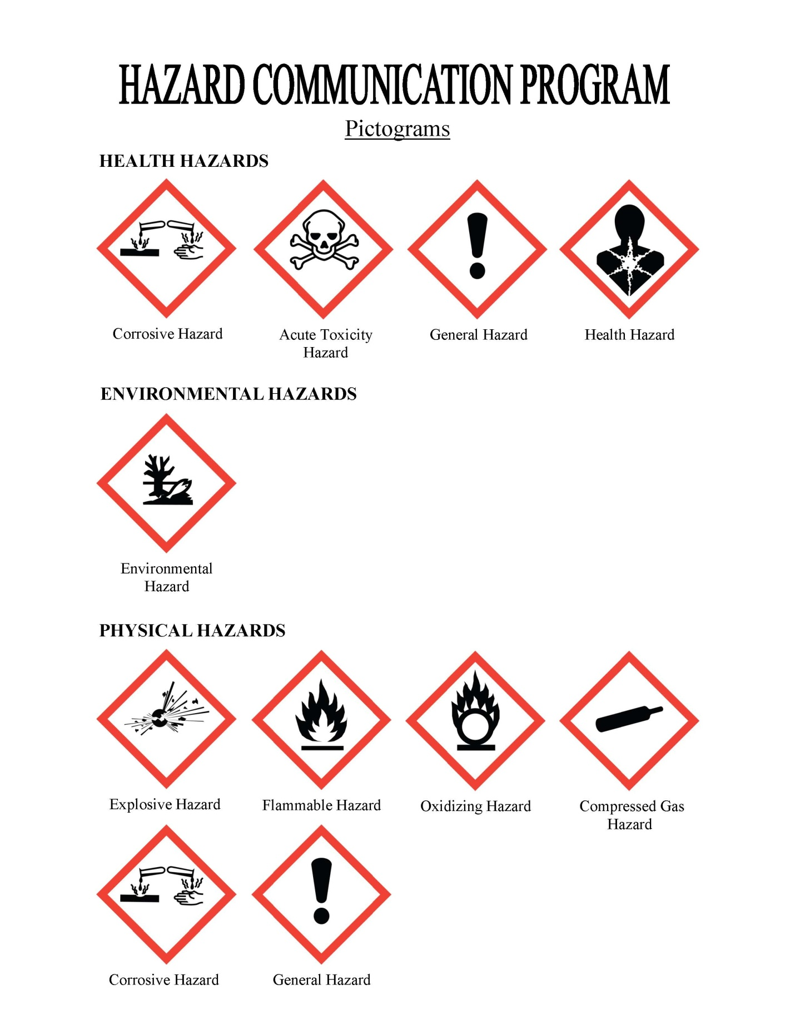

Appendix C
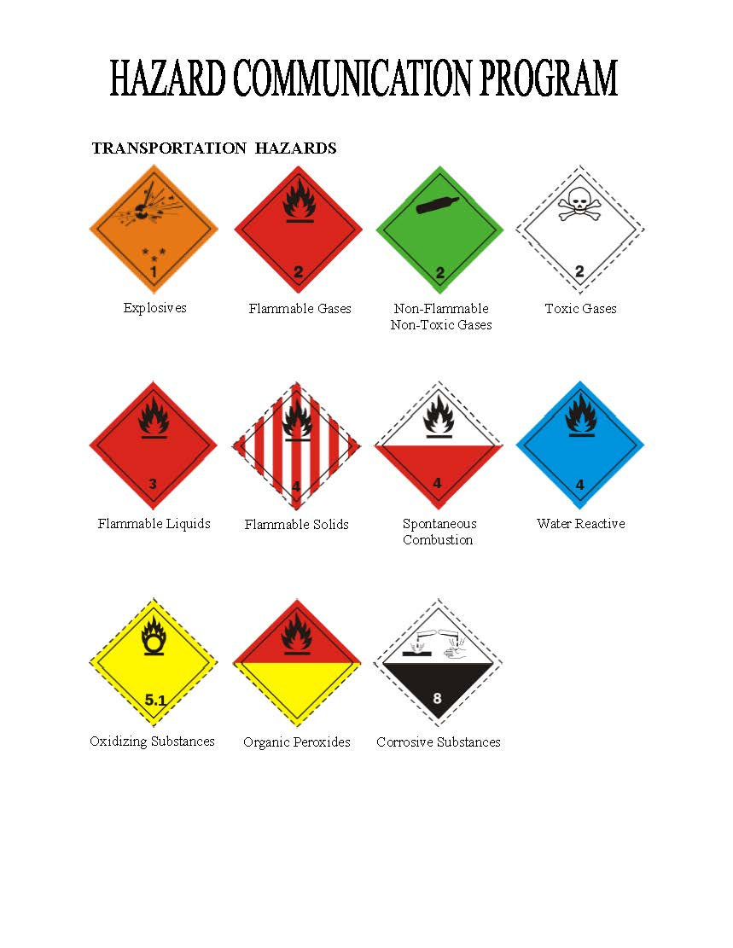

Appendix D

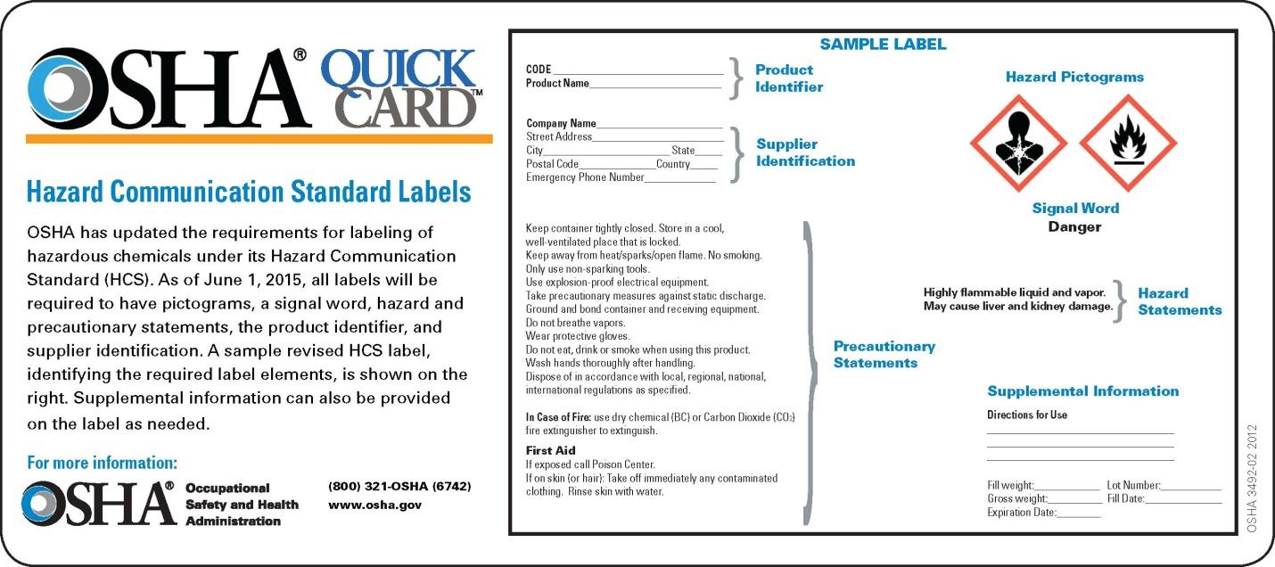

Origination Date:
January 15, 2016
Reviewed by Safety Committee on:
October 21, 2020
Last Amended Date:
January 15, 2016
Next Review Date:
October 21, 2023

Approved:

___________________________________________ ____________________
Peter H. Owen Date
Bath City Manager

CITY OF BATH
ACKNOWLEDGEMENT OF HAZARD COMMUNICATIONS POLICY

I have read and understand the City of Bath Hazard Communications Policy. I have received a copy and know where to access a copy for reference.

I understand that I must abide by all procedural rules and that failure to do so can result in disciplinary action up to and including termination.

Signed: _________________________________

Printed Name:____________________________

Date: ___________________________

